SHOWWCASE ENGAGEMENT ANALYSIS REPORT

OBJECTIVE: User Engagement Analysis of showwcase platform on OCT 2019.

BACKGROUND: Showwcase is an online platform where members of the tech community connect, share their knowledge, work experiences, projects built, people they've worked with - and find new opportunities. Showwcase users can like, follow, comment, and share posts on the platform. The company's goal is to build a platform that encourages users to share, exchange ideas, connect, and learn from other users.

AIM: In this project, to better understand the "user engagement" on the Showwcase platform, I VISUALIZED and ANALYZED the data of October 2019. The goal is to help Showwcase make improvements in the business and get noticed. The project is done by Python and Tableau.

- I have used tableau for data visualization please find the link to view the interactive dashboard.
- And I have used python for data cleaning and data exploration, visualization

EXPLORATORY DATA ANALYSIS OF THE DATASET:
Exploratory Data Analysis is the process of exploring data, generating insights, testing hypotheses, checking assumptions and revealing underlying hidden patterns in the data.
The dataset has about 302 rows, each containing Customer id, Bugs Occured, likes given, comments added and session duration , and other information for each ession. Our objective is to use this data, explore it, and generate insights from it.

User engagement measures whether users find value in a product or service or in a website. Engagement can be measured by a variety or combination of activities such as downloads, clicks, shares, and many other factors. Highly engaged users are generally more profitable. To Improve the users in a session or a website the main thing is to create an attractive content , so that the visitors find them useful.

DATA CLEANING: For data cleaning in showcase sections dataset, I have used python for basic cleaning :
- Clearing up null values
- Renaming the columns to much sensible labels
- Skipping unnecessary columns

DATA TRANSFORMATION: The dataset was already in a good state of converting raw data into insights .

DATA EXPLORATION: The main objective of data exploration is getting to know the data for insights, I have used python and tableau for the findings.
The necessary information/Insights I tried to get:

The shape of the data after cleaning has 299 rows and 14 columns.

- How many projects were added on week days in oct 2019?

Saturday had the highest count of projects added around 55.

- How many likes were given on weekly basis per session?

Saturday and monday has the highest session likes.

- No of projects added by login date.(Time series trend)

- How many projects were added per session? 220

- how many likes were given to projects: around 220

- how many comments given per session : around 220

- how many users are inactive during a session : around 170

- how many users are Bugs during a session : around 170

- No of Bugs occurred by login date?

- Count of bugs per session.

TABLEAU DASHBOARD Answers the following INSIGHTS:

- Top 10 most and least active customer based on Sum(Comments + Likes + Projects).
- On Average how many projects are added, comments given , and Likes given by a particular user during a Session. This can help in targeting user based on their activity.
- Target users who are least liking the projects on the platform and can ask for their feedback.

- Top 10 most and least active customer based on Session Duration.
- Target users who are not following significant number of projects. Like the relevance of projects to them through interests.
- Day of a week on which user is most or least active based on follow and like counts on that day.

System Performance and User retention

- Top 10 customer with most bugs and inactive duration:
- Track the average count of bugs occurring during a session. This can define the scope for the technical optimization of the platform.
- We can find the map of session duration and Bug count , this can help us find out following .If the session is large and Bug is more , this means user is staying on the session because its difficult to use because of bugs.
- User Engagement Analysis of important cards: Maximum projects added , Total Projects, Average session Duration, Total Session likes, Maximum comments added.
- No of projects added with respect to login date and no of bugs occurred with date.(time series plot)
- Count of session Projects added on week days.
- Engagement of customers on each week day, Its average duration, Session projects added , Maximum likes given and Max comments.

DATA VISUALIZATION: I have used tableau to create an interactive and user friendly dashboard of user engagement analysis of user. Please find the link to view the dashboard, play around with data to see amazing visualizations.
Link to the viz:
https://public.tableau.com/profile/rohini.kanungo#!/vizhome/showwcase_USerEnagement/Timeseries_projects

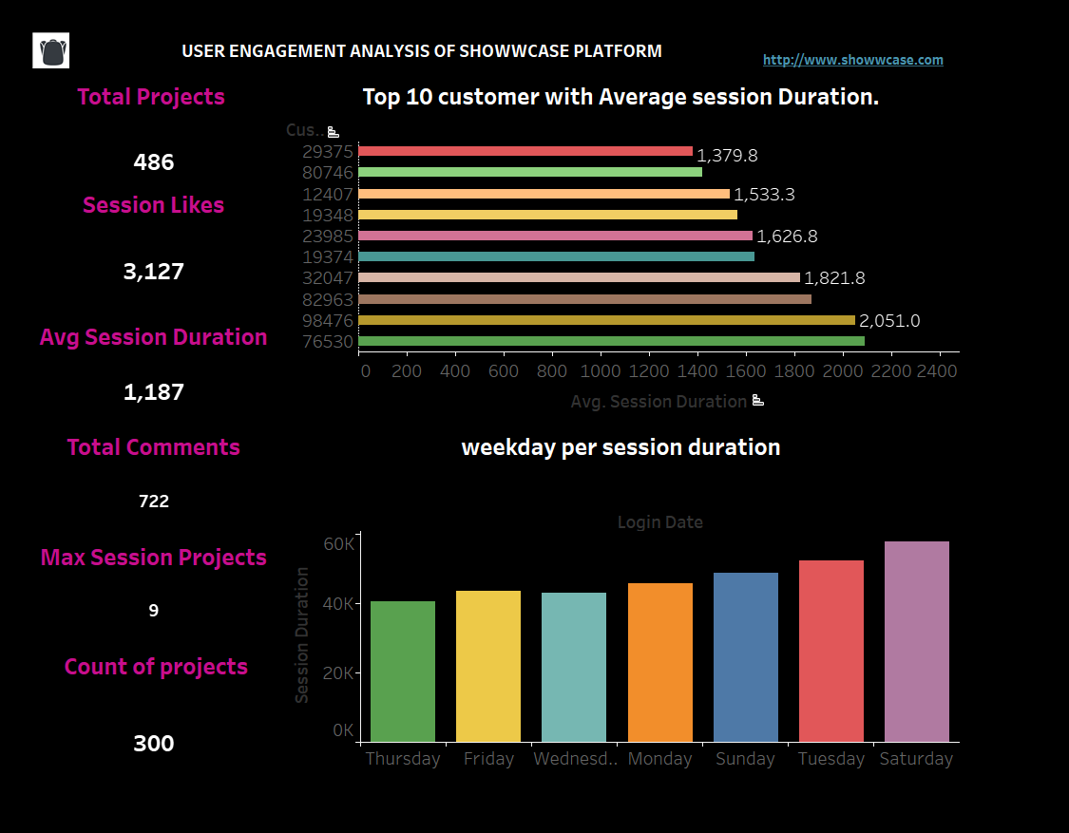

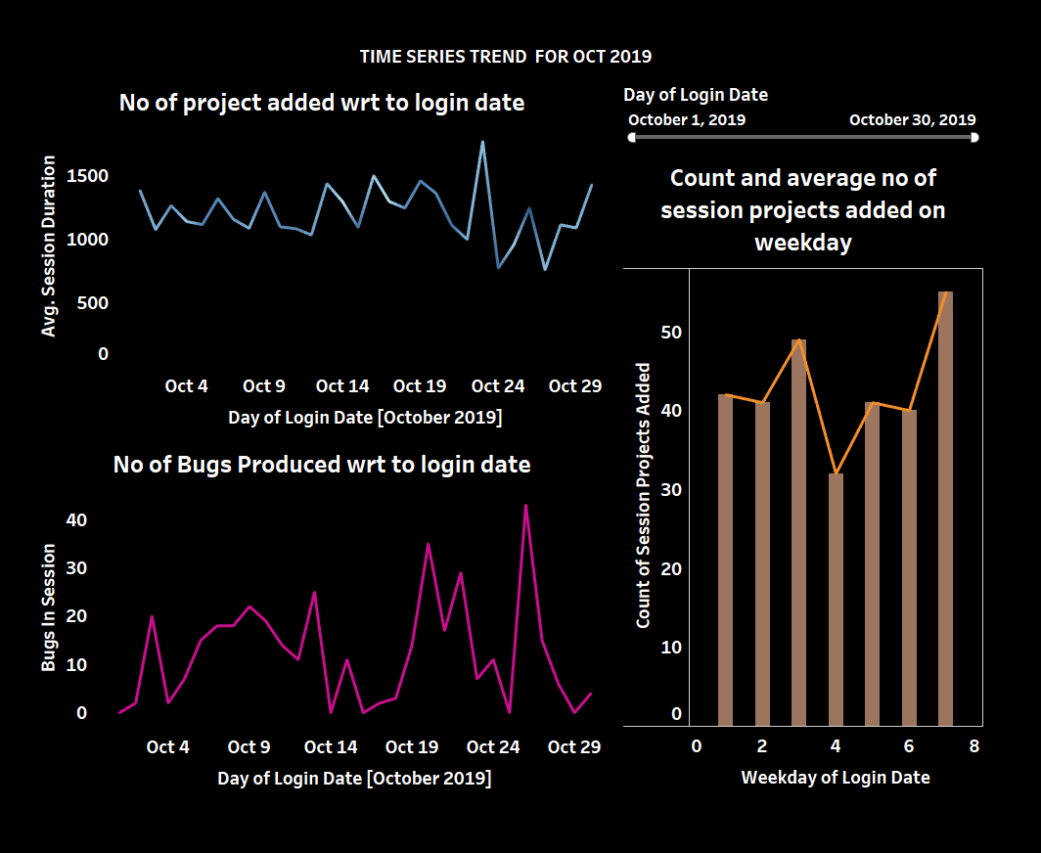

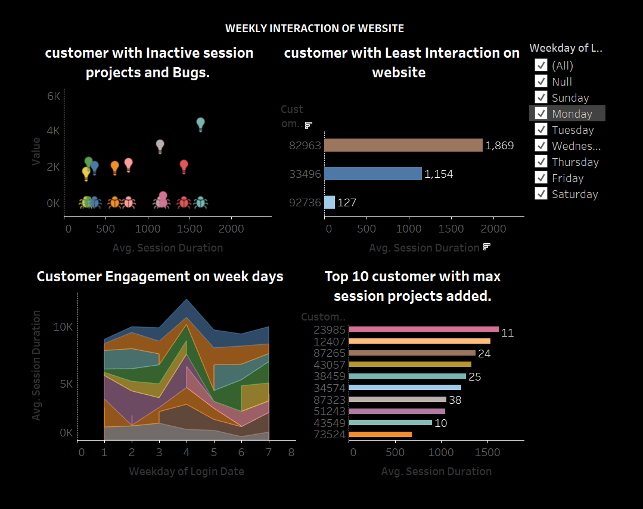

RECOMMENDATIONS:

I have found the insights based on the dataset given, But there are few more metrics if added we can find more insights on the behavior of the customers.

- Age: If we get age based on Gender, we can target audience of that particular age group who are in college / School who wants to showwcase their work as a eportfolio.
- Bounce rate: Users who bounced back after the landing page, this can effectively determine if the users find the website useful and spend adequate time on all pages.
- Visitor type: New and Returning Visitors. We candetermine how long new or returning customers spend on the website, if a returning users percentage is high we can say that, users find our website interesting.
- Region(Demographics):Where do Users come from (region)?
- #Which page of the website (home/Projects/) are new vs returning customers more likely to spend their time?
- Exit rate: the no of users who exited from the page without doing anything.
- Social Channels: We can get good insights on how we are acquiring the users for example: Direct, Google search, linkedln, referral. This will give the social marketing team to target the platform which acquired least users.

